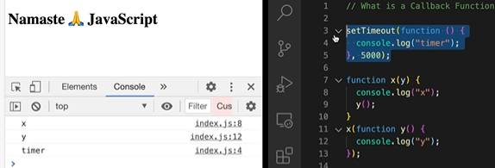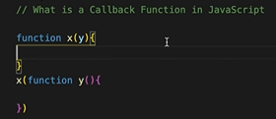



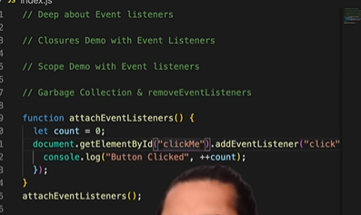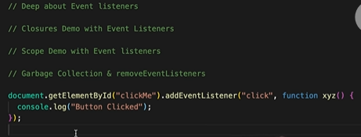



Things learned:

1. Function that is passed on as argument to another function is called callback function., In order to be called back in future.

2. setTimeout helps turn JS which is sinhlethreaded and synchronous into asynchronous.

3. Event listeners can also invoke closures with scope.

4. Event listeners consume a lot of memory which can potentially slow down the website therefore it is good practice to remove if it is not used. ,they are with lots of scope and closers